1. Power BI welcome window

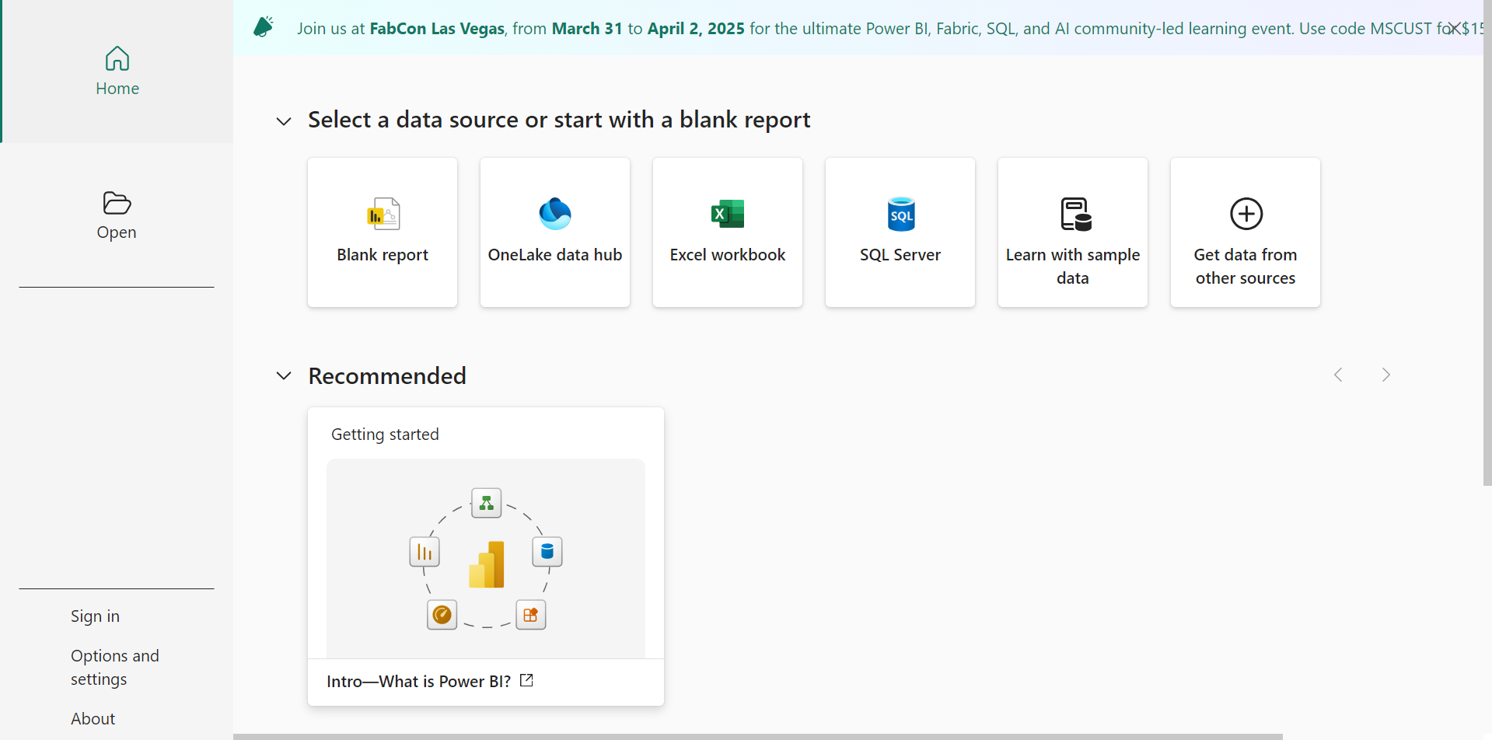

1. Power BI Desktop

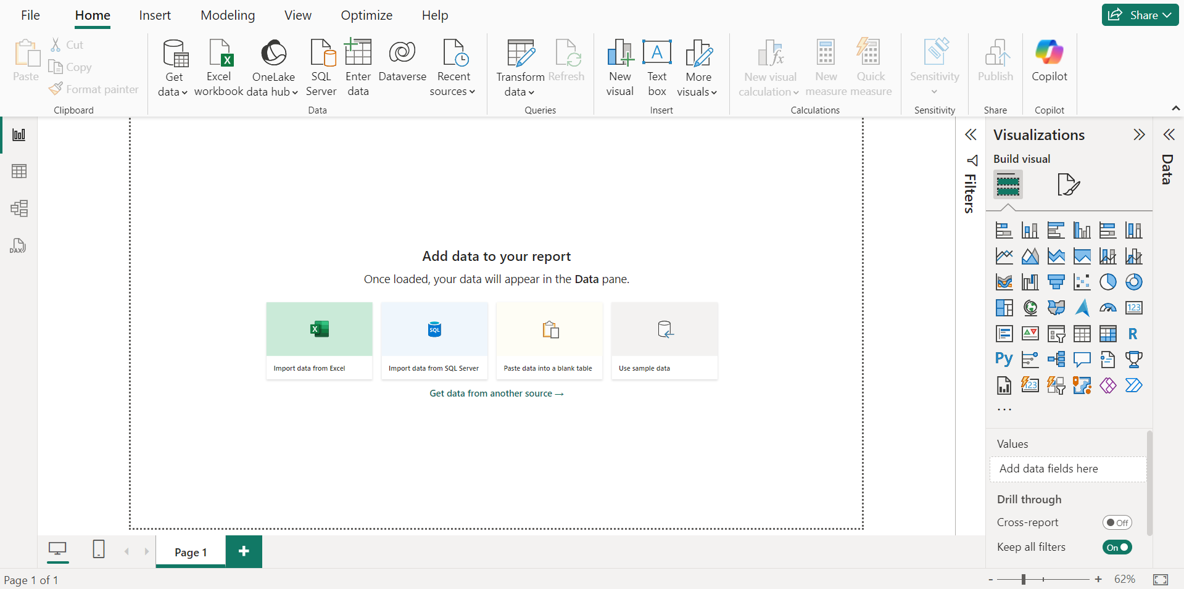

1. Get data option : We would we clicking on text/csv as our data is a csv file.

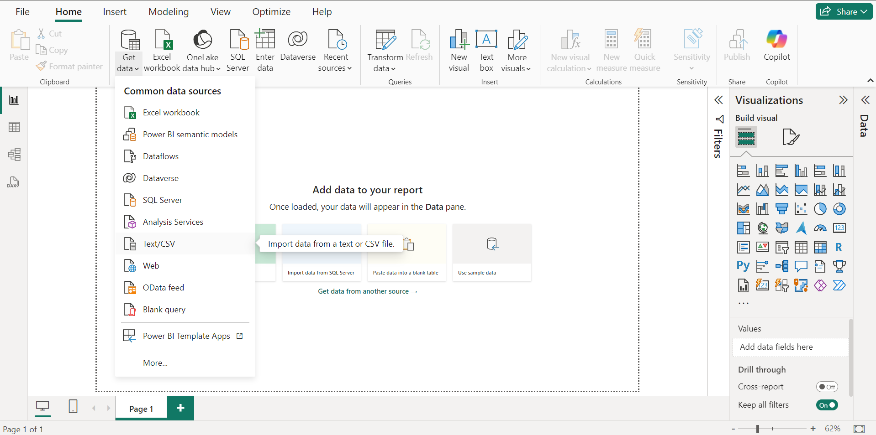

1. Opening our Data file : Exhaustive analysis of Indian Agriculture.

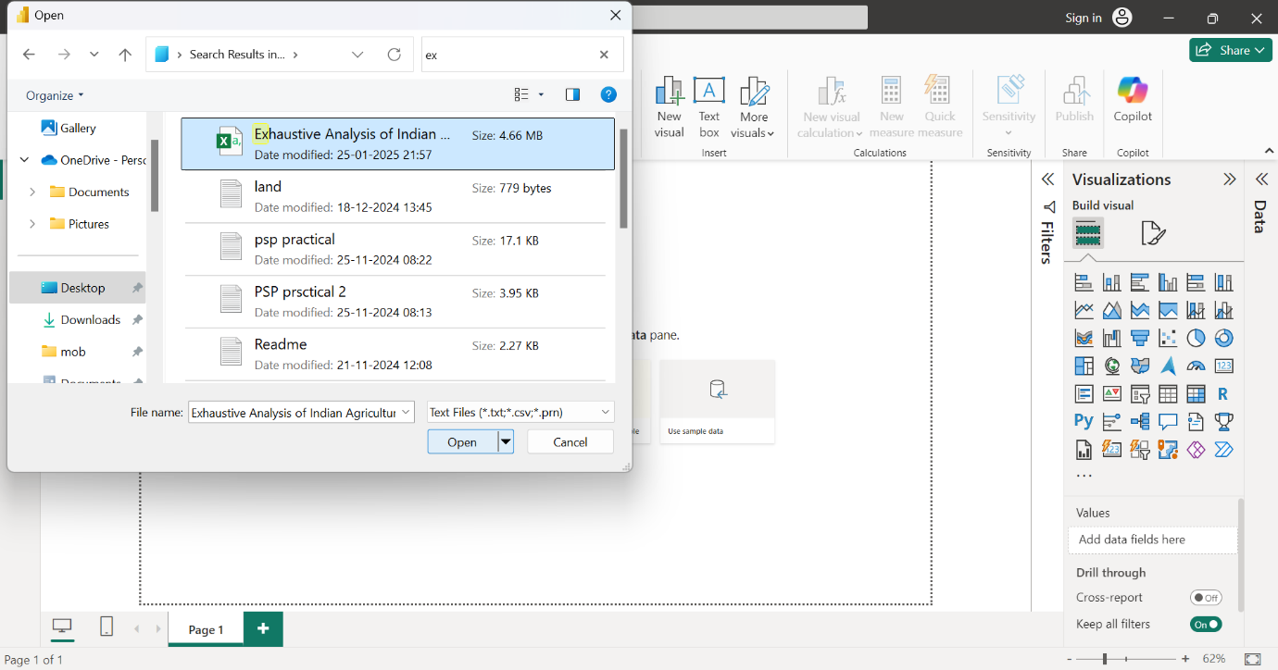

1. Opening the data file we would see options like load and transform. We would be clicking the load button.

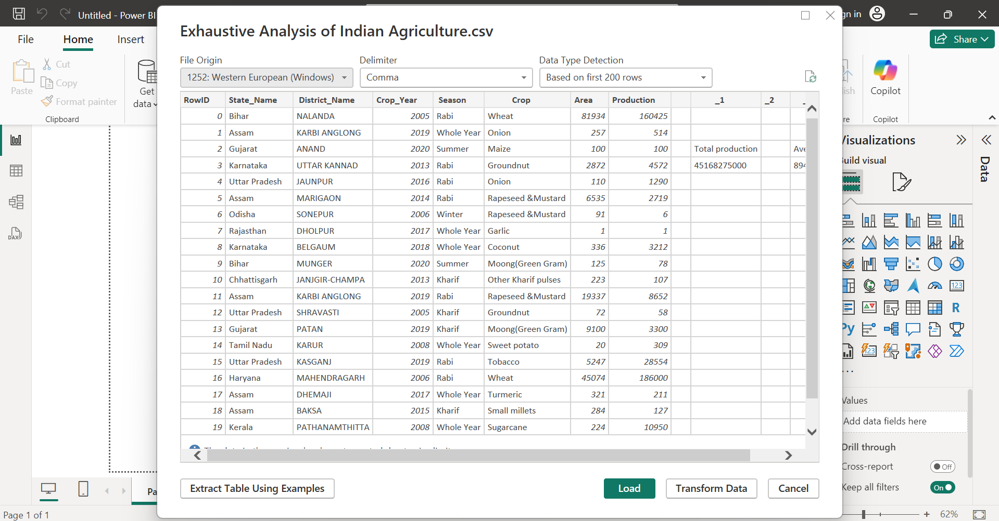

1. Data File loaded.

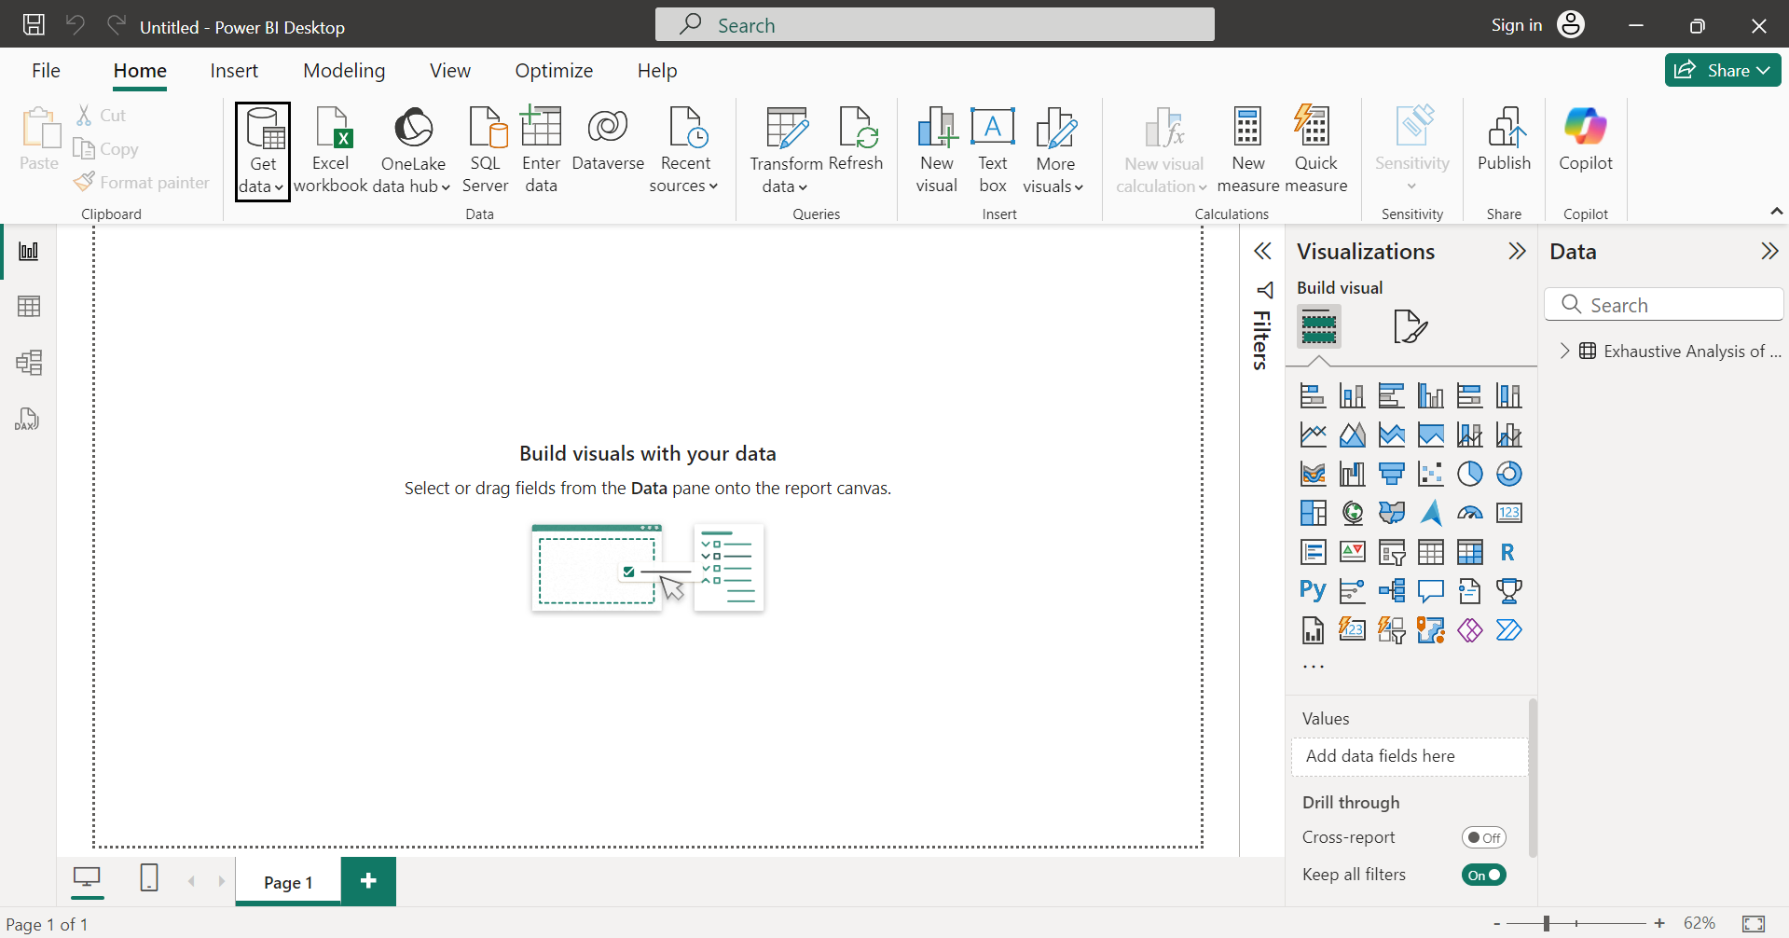

1. Report view : perform visualization

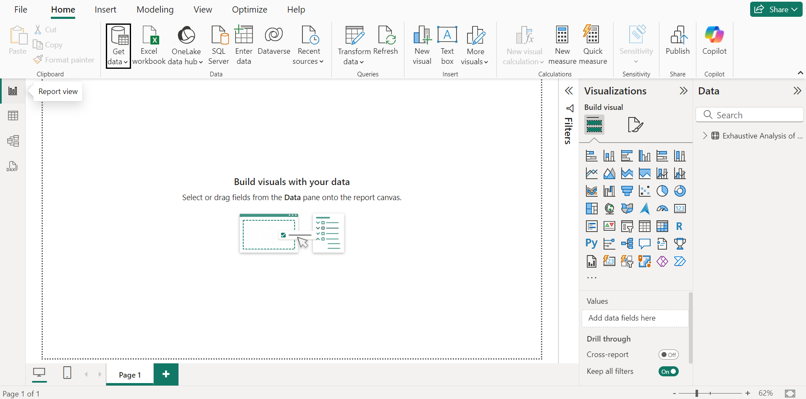

1. Table view : See our data

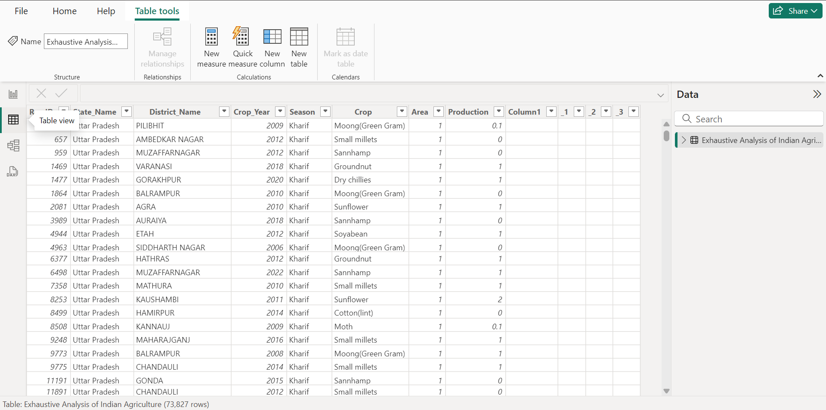

1. Model view : Can create relationship among data.

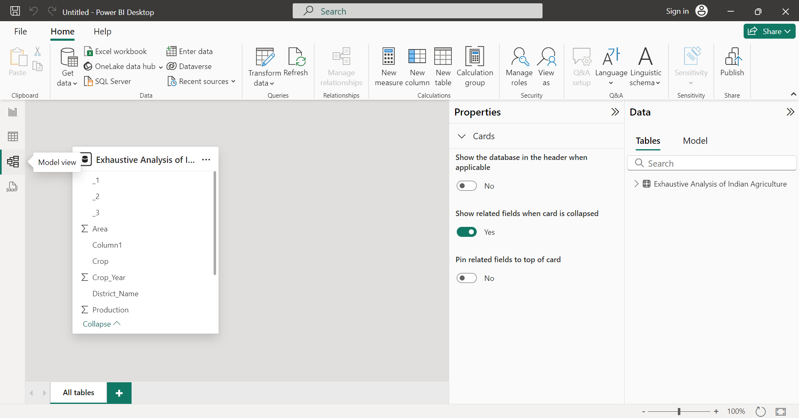

1. Clicking on transform data button.

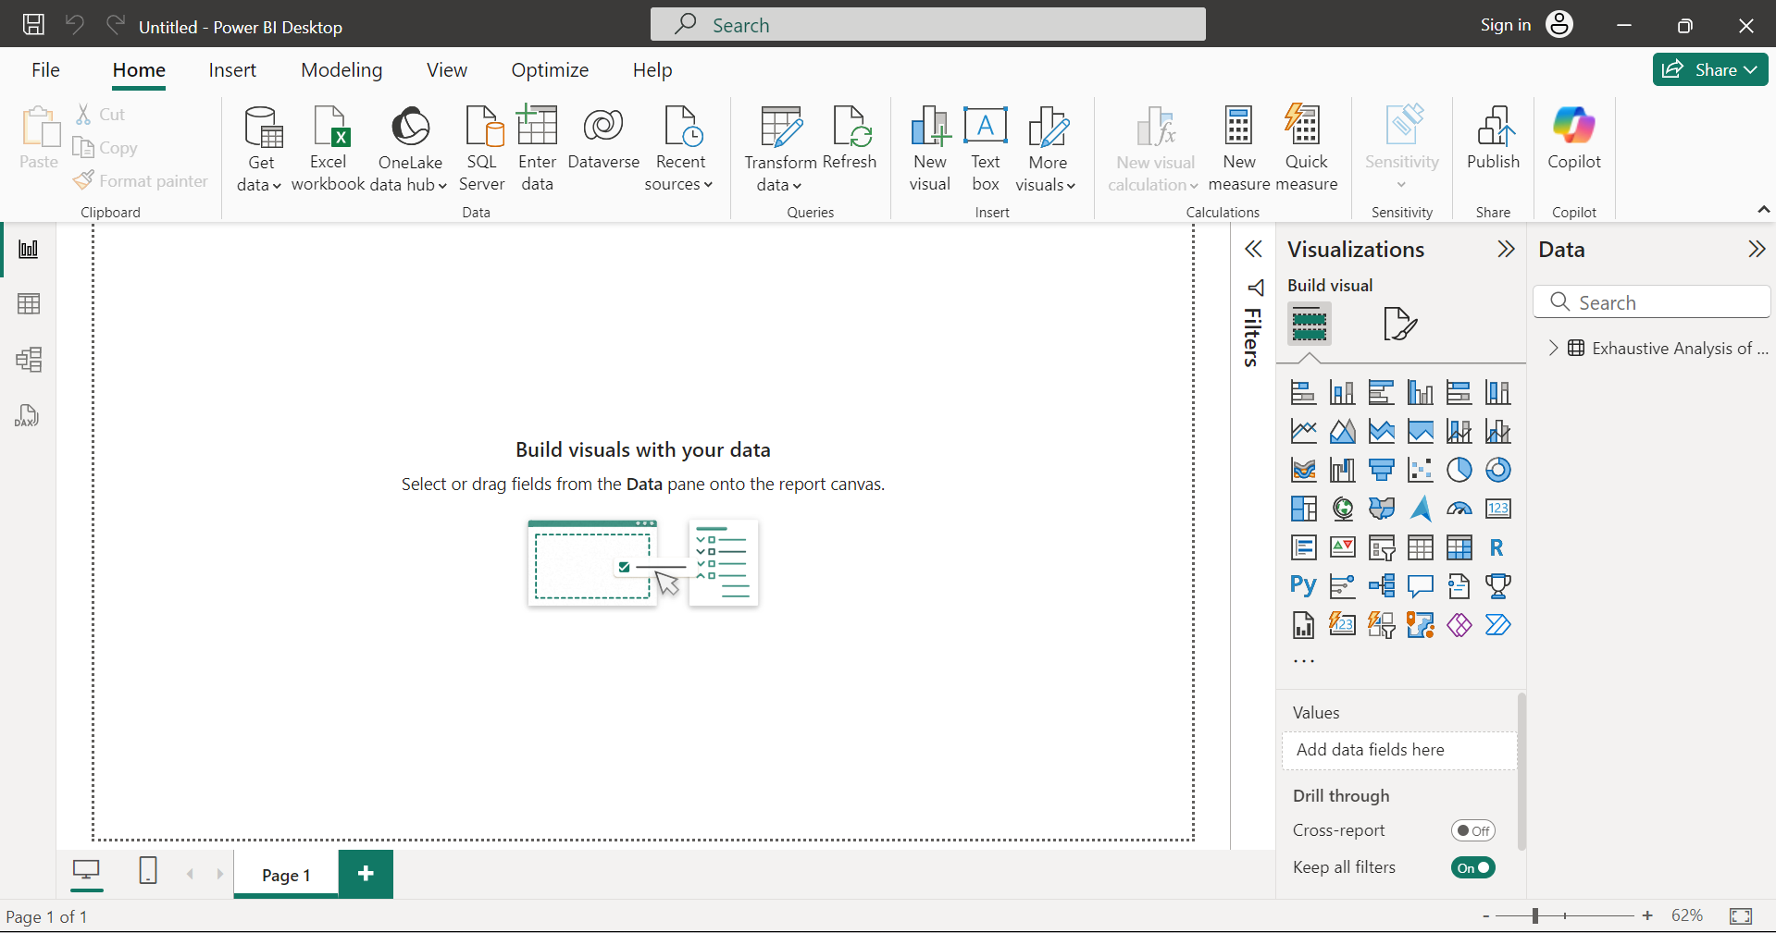

1. Power Query Editor window. In this window we can perform all the cleaning process.

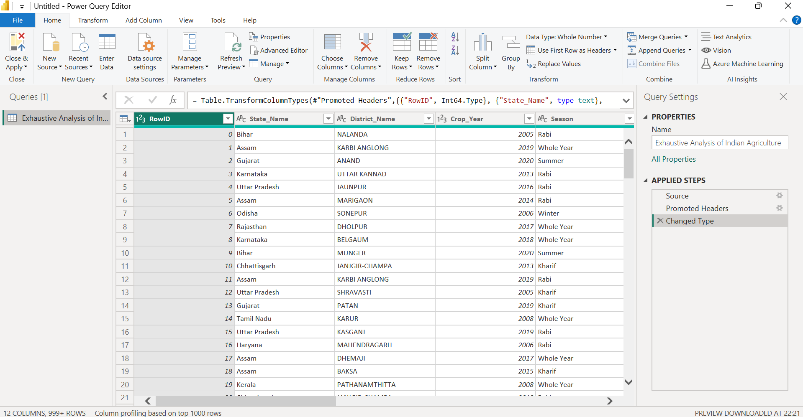

1. Columns :
2. Row id column
3. State column
4. District Name
5. Crop Year
6. Season
7. Crop
8. Areas (hector)
9. Production



1. Removing unwanted columns. We can also undo the changes.

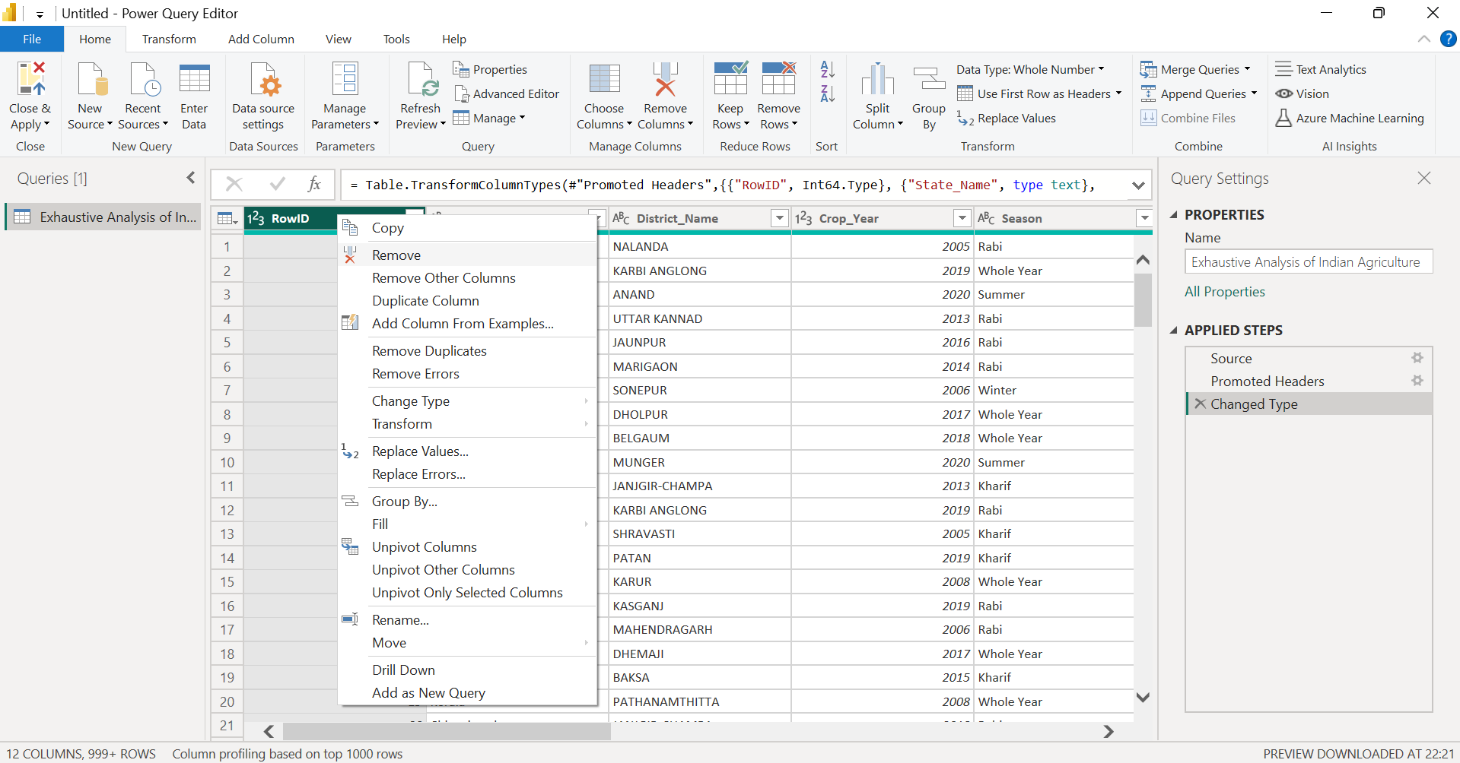

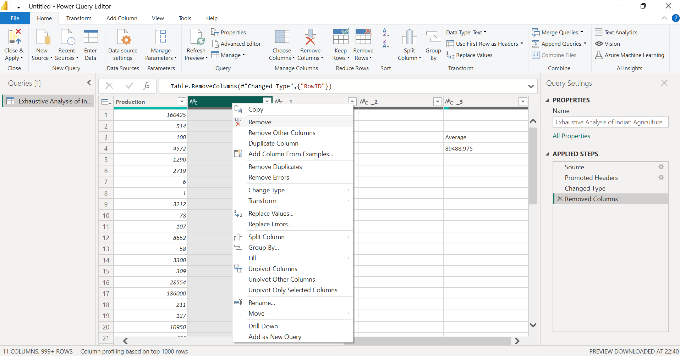

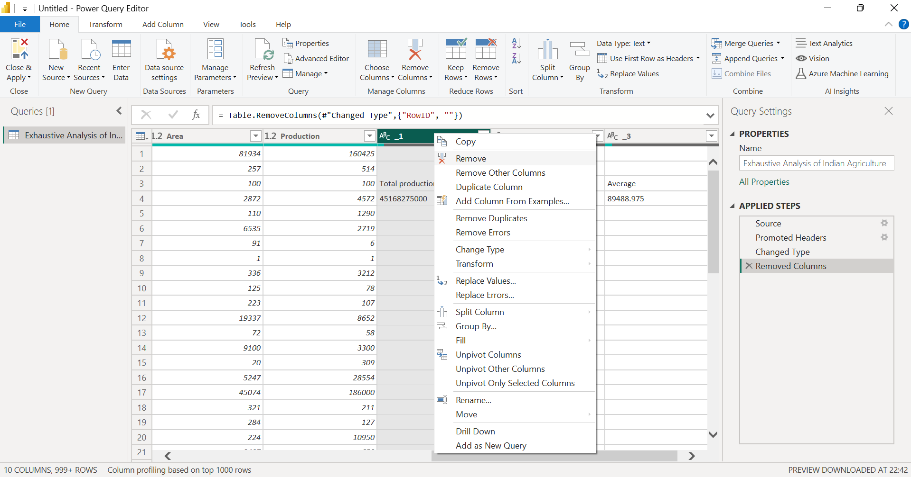

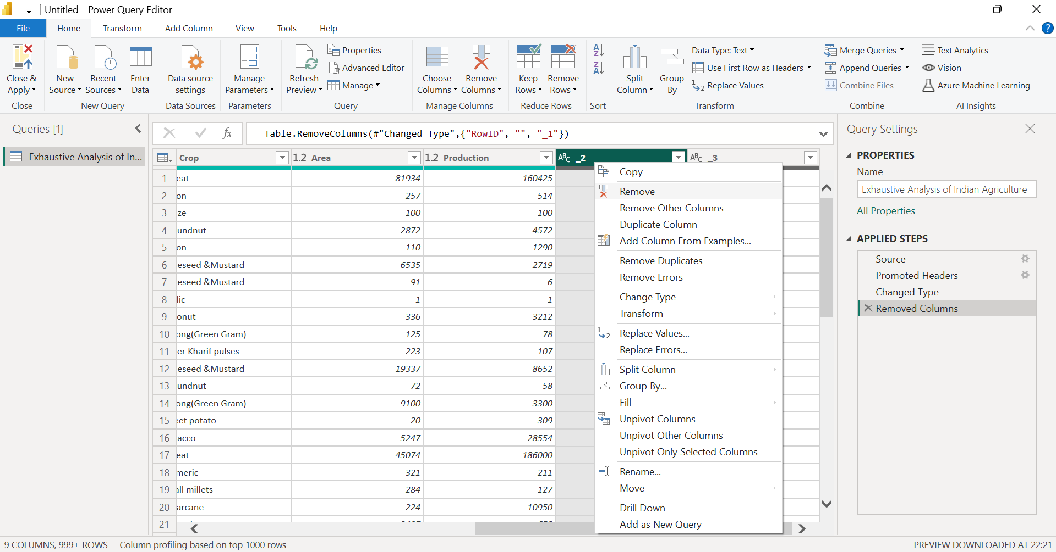

1. Clicking on view tab and then column quality option.

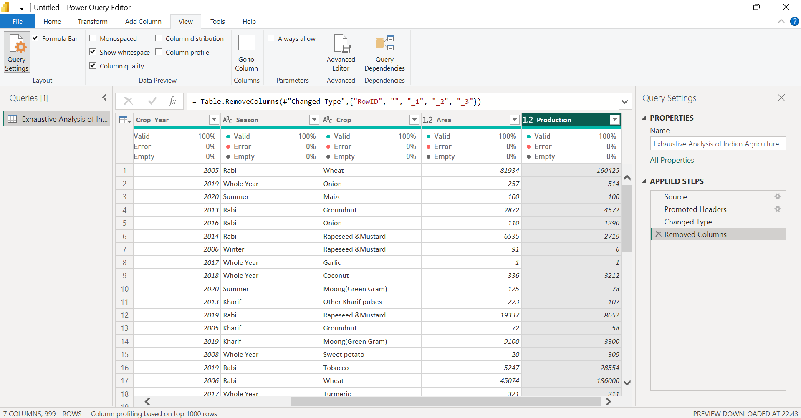

1. Checking for empty/null values.

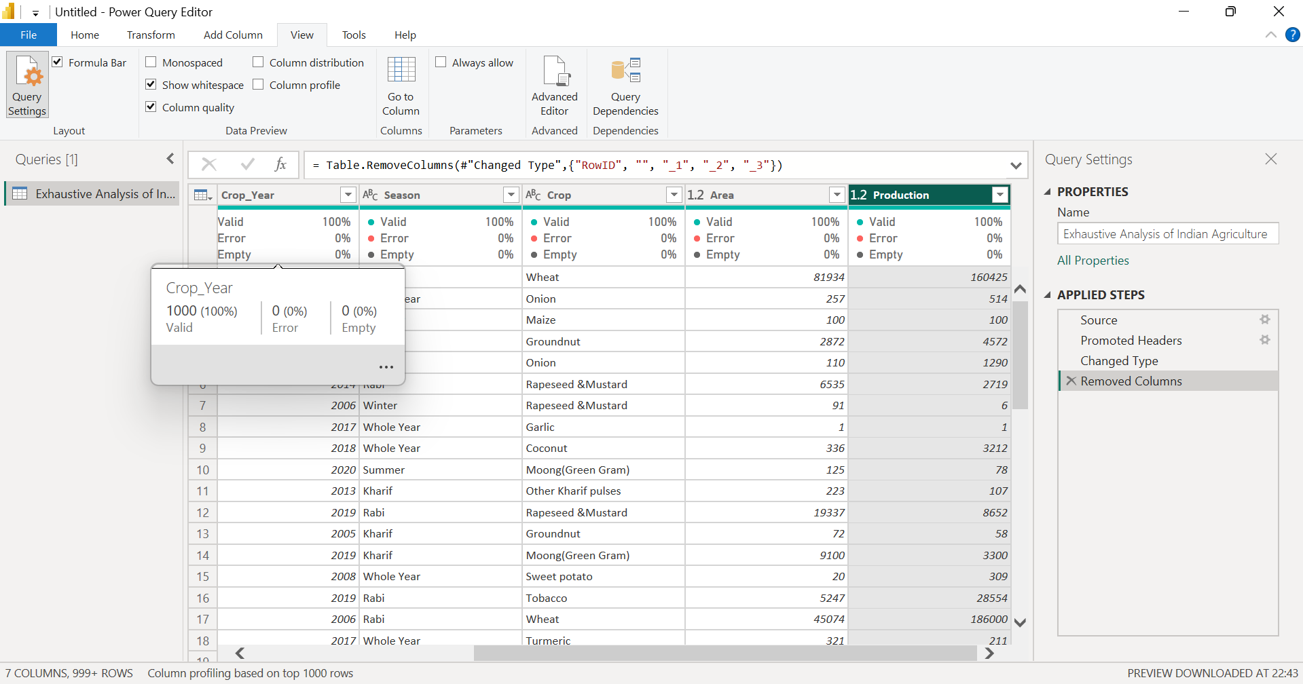

1. If we have null entries or rows, we can remove them by clicking on remove rows and then clicking on remove blank rows. Also we can perform more functions like remove duplicates and remove error.

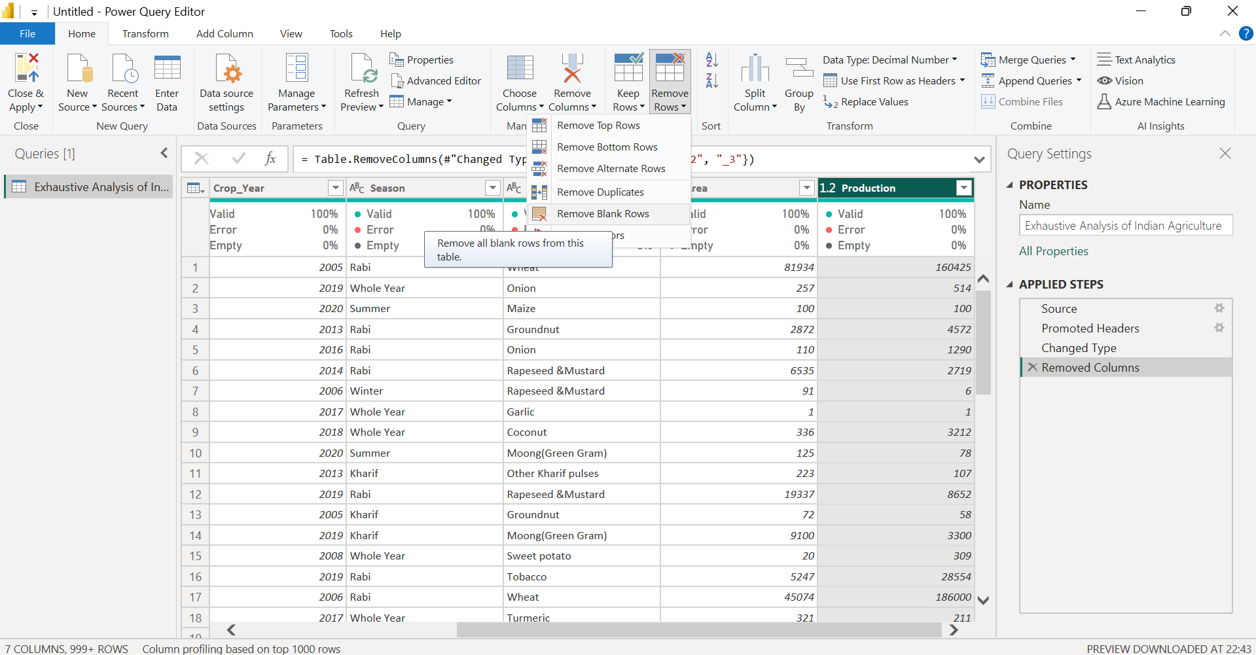

1. We can also change the datatypes.

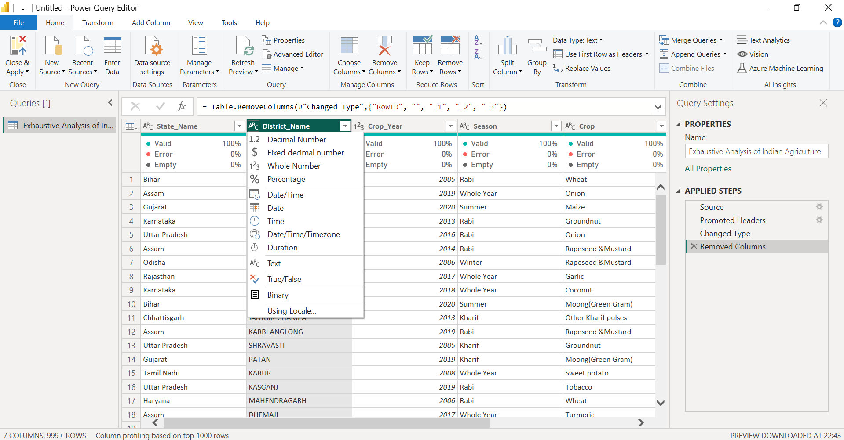

1. Clicking on close and apply button to save the changes.

